Disclaimer:

This document is only meant for the **staff** of **Pathfinder Youth Centre Society** who are **authorized** to handle application files and its backup.

As a PYCS staff member, **DO NOT**:

1. Copy and distribute this document without instruction to do so
2. Share or talk about this document with unauthorized personnel
3. Share this document to the public

Pathfinder Youth Centre Society File Backup Documentation

Table of Contents

**Introduction** **5**

When reading instructions 5

Purpose for backup 5

Quick Explanation 5

**Security** **7**

Introduction 7

Rules 7

Disclaimer 8

**Downloading Backups** **9**

Introduction 9

Backup File Format 9

How to download the backup 9

Additional Notes 10

**Storing the Backup Files** **11**

Introduction 11

Folder Hierarchy 11

Application Folder Format 11

Applications with missing data 12

Verifying the ZIP file contents 13

Checking the ZIP file size 13

Verifying Application Files 13

Cross checking with the Staff Login Portal 13

Cross checking with Firebase 15

Storing the ZIP file 18

**File and Folder Navigation** **19**

How to find a specific application folder in the Cloud Storage 19

How to delete the Cloud Storage to make more space 21

**Firebase Cloud Storage Management Suggestions** **24**

Introduction 24

Data storage and transfer limits 24

Suggestions 24

Storage Plan: One download every month 24

Storage Plan: One download every two weeks 25

**Author Notes** **26**

# Introduction

This is the documentation for the staff of Pathfinder Youth Centre Society (PYCS). The following sections in this document will outline the instructions and precautions of backuping the server. The purpose of this document is to give readers a more in-depth understanding of how to

Please refer to this document whenever you are unclear on or have forgotten how to backup the application files.

If you need to refer to a specific action, please scroll down to the section that talks about that action. You **are not required** to read every section of this document to understand how to handle the backups, but it is highly recommended that you read the entire document if this is your first time handling the backup

## When reading instructions

Please read the instructions clearly and do not ignore warnings/disclaimers. Warnings will indicate consequences to actions when the following step is done. Warnings will be highlighted in red. Disclaimers indicate logical difficulties that might occur. Disclaimers will explain what you might be experiencing and give an explanation as to why it is happening. Disclaimers will be highlighted in blue.

Warning = red

Disclaimers = blue

## Purpose for backup

PYCS has requested a solution to backup application files. The purpose of these backups is to allow PYCS to keep old application files if they ever need to refer to it, and make sure that the Firebase Cloud Storage doesn’t hit it’s storage limit.

While these backups are created it is important to **maintain both** the live Firebase Cloud Storage and the external hard drive that stores all the old data. We want to make sure that data in the Cloud Storage doesn’t get filled up too quickly since there are restrictions to a free Firebase account.

## Quick Explanation

A very, very short explanation of the whole process. This is just so you understand the overall idea of what is trying to be accomplished. **DO NOT use this as a guide for actually storing the backup files. Please read the full instructions in the sections below for a proper guide.**

1. Download the backup files (this should be a ZIP file)
2. Make sure to verify the contents of the ZIP file to check if the files are actually downloaded or not
3. Move the ZIP file into the external hard drive
4. Verify the contents of the ZIP file in the external hard drive and make sure the contents have copied over successfully
5. Delete the original ZIP file stored on the device (if it is still there)
   1. Make sure to go into the recycling bin and delete it from there as well so it can not be restored
   2. If a copy of the ZIP file was moved into the external hard drive and not copied, then the ZIP file should no longer be on the device
6. Handle the external hard drive as instructed from Ruth or the leading administrator (staff responsible) for file backups

# 

# Security

## Introduction

To maximize security it is important that staff follow these measures to reduce the risk of a data leak. You are handling personal data and it should be treated and handled as if all of this personal data is your own. Because of the method we are using to create and store backups it is crucial that instructions are followed closely and the rules are understood and practiced.

The rules describe how to handle the data when it is in your possession.

## Rules

**Any staff unwilling to follow the rules listed below increase the risk that personal applicant data is leaked. Please be considerate.**

As a PYCS staff member it is **your responsibility** that:

1. The backup files are never uploaded online to any platform or file sharing service
   1. Follow this at your discretion with regards to rule 3
2. The backup files are never kept on a personal (non-work) device or in personal storage
3. The backup files are never sent to other people (even other authorized staff) using messaging/file sharing platforms
   1. Follow this at your discretion
   2. We understand that there are scenarios where files need to be sent to other authorized people. Please just be aware of the risk that is being taken if this is done
4. The backup files are only in possession of those authorized and affiliated with PYCS
5. The backup files should not be open in the presence of unauthorized personnel and people
6. No screenshots, pictures, video recordings, or video streams should be happening while these files are being accessed
7. You are always at your device while any application files are open. Do not leave your device unattended while application files are open
   1. Follow this at your discretion
8. Like personal data, you never talk about the contents of the backup to anyone that isn’t authorized to handle application files
9. Do not allow unauthorized personnel and people to handle the external hard drive that holds all of the backup files
10. You are aware of the external hard drive and where it is being stored while it is in your possession

To reiterate these rules are the ones that we **highly suggest should** be practiced to prevent a data leak from occurring.

## Disclaimer

However, if Ruth or a higher level PYCS administrator has directed you to do different security practices, please listen to them and use your best judgement to protect the applicant data.

# 

# 

# Downloading Backups

## Introduction

This section talks about everything relating to downloading the backups. It will talk about file format, navigation, and handling.

## Backup File Format

The backup file is a compressed ZIP file that is downloaded directly from the Staff Login Portal.

The naming format for zip files is as follows:  
  
yyyy_mm_dd_HHMMSS



e.g. 2021_01_02_130133.zip. This ZIP file was downloaded on January 2nd, 2021at 13:01:33

The order for the format is year, month, day, hour, minute, second.

The format is like this to make it easier to identify when a ZIP file was downloaded.

## How to download the backup

Instructions on how to download the backup ZIP file.

1. Log in to the admin page through the Staff Login Portal
2. Locate the tab on the left that says “Backup Files” and click on it

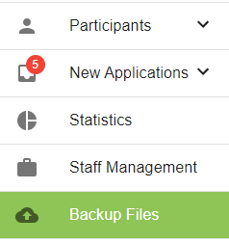

1. You will see the Backup Files page. Click on the “BACKUP FILES” button to download all of the application files

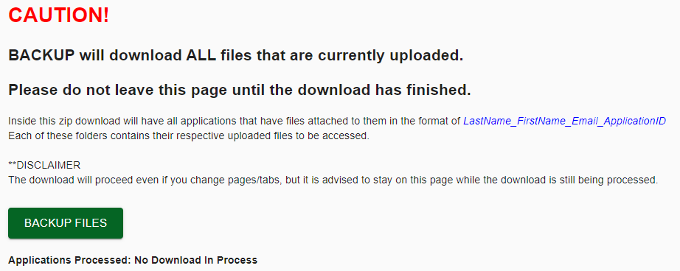

* 1. Depending on how many files are in the Cloud Storage this could take a while

## Additional Notes

More information regarding the use and the interactions that occur while downloading a backup file.

1. If you click on the “BACKUP FILES” button, you can still access the other tabs of the website. The download will occur the moment the download is ready.
   1. Applications Processed will no longer start counting if you switch tabs
2. Refreshing while waiting for a download to occur will cancel the download
3. The ZIP file will have a “README.txt” that has a set of notes and instructions
4. If an application is deleted from the database but its files are still in the storage, those files will also be downloaded to the backup ZIP file
   1. We suggest that files that belong to no applications be cleared from the storage to make more room for other files

# 

# Storing the Backup Files

## Introduction

This section is for understanding what to do with the backup once it has finished downloading.

## Folder Hierarchy

The ZIP file will have an “Applications” folder that has sub folders. These sub folders are the applications and their files. **Only applications that have files uploaded to it will have a folder**. Inside the sub folders will be the files to their specific application.

The ZIP file will follow this hierarchy:

* Applications (folder)  
  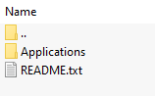
  + (folders for each application)   
    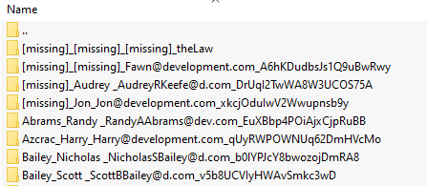
    - (files for that specific application)  
      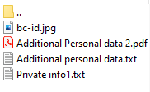

## Application Folder Format

The folders for the applications are named using this format:

[Last Name]_[First Name]_[Email]_[Application ID]

e.g. 

The last name, first name, and email are identifiers to make searching for a specific folder easier. Follow the format with the information given from an applicant to find their folder.

Disclaimer: The backup ZIP file takes **the most recent data** of an application. If a backup file is downloaded and then an application, that has files in the backup file already, has any of the identifiers changed, you will have trouble finding an applicant’s folder in the older ZIP files because the data is no longer matching. Please be diligent when looking for an applicant’s folder.

Disclaimer: If you are searching for a specific folder and you’re unable to find it, there are a couple reasons why.

1. At the time of the backup file download the applicant didn’t have their file uploaded yet
2. Files from the Firebase may be deleted in the future to make more room for newer files So it might not be in newer versions of the backup ZIP files
   1. Please make sure you’re searching backup ZIP files that are around the time an applicant has submitted files
3. Someone may have deleted the folder in a previous session when they were accessing the backup files

The Application ID is meant for those who want to search for a specific folder in Firebase Storage. We’ve left the Application ID in case anyone ever needed to reference a folder in the Firebase Storage

### Applications with missing data

The naming for the application folders takes the data from the application itself. Meaning if any of this data is missing there would be blank spaces in the folder names. We’ve changed this to replace missing data with “[missing]”.

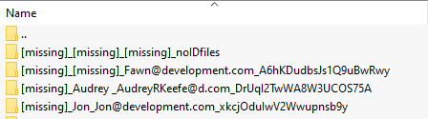

## Verifying the ZIP file contents

We need to make sure that the contents of the database have been properly downloaded from the database. There are a few checks that can be done to indicate whether the files have been downloaded or not.

### Checking the ZIP file size

In the location of where the ZIP file was downloaded or transferred to you want to check that the size of the ZIP file **is NOT 0**.



In this case the ZIP file that is downloaded has a file size of 494 KB.

If this ZIP file has a file size of 0, then there was a problem in the process of downloading the back up.

If this ZIP file is transferred to another location and its file size is 0, there was a problem in the process of transferring the file.

SOLUTION: Download or transfer the file again.

If there is a consistent problem with downloading the files, it could be a problem with the website or Firebase.

We’re unable to provide a definite solution as to why transferring the ZIP file isn’t working.

### Verifying Application Files

The next step that can be done is to verify the files of specific applications. To do this you will cross check the files from an application to the ones in the ZIP file to see if they match.

There are two methods that can be done to do this. One that uses the Staff Login Portal and the other that requires access to the PYCS Firebase account. Instructions for both are provided.

Note: It is **highly recommended** that you verify multiple applications to ensure that the ZIP file has downloaded properly.

#### Cross checking with the Staff Login Portal

1. Find an application in the ZIP file that you want to cross check. Open this folder to see its contents  
     
   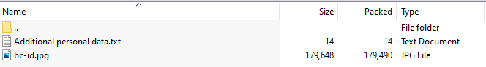
   1. You will want to select a folder that has at least a first or last name (jus to make things easier)
2. While in the Staff Login Portal go to “Participants” and find the application using the search feature. Use the applicant's last or first name to find the application.



1. Access the correct application and access the “Files” tab on the left. A list of files should appear

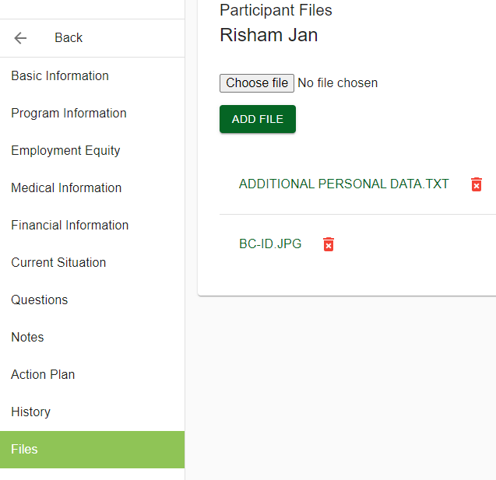

1. Cross check the files on the website with the files in the ZIP file and make sure all the files are the same.  
   

#### Cross checking with Firebase

This method requires you to have access to the PYCS gmail account so you can access Firebase. If you do not have access to this, this method can not be done. Please request access or use the first method using the Staff Login Portal.

1. Find an application in the ZIP file that you want to cross check. Open this folder to see its contents

  
  


* 1. You will want to select a folder that has at least a first or last name (jus to make things easier)

1. Make sure you log into the PYCS gmail on Firebase.
2. Click on the “pycs-database-app” project

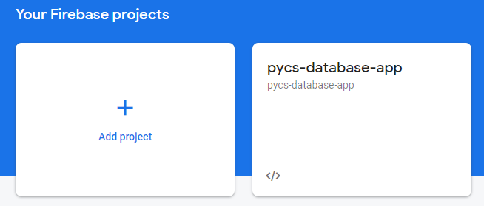

* 1. If you are not on this page, click on “Go to console” on the top right of the website

1. Click on the “Storage” tab on the left panel

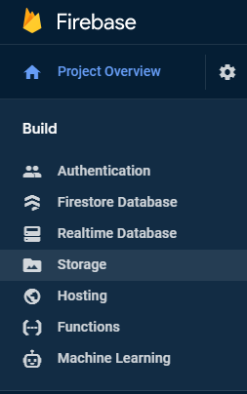

1. You will see an “Applications/” folder. Click on it to access its contents.

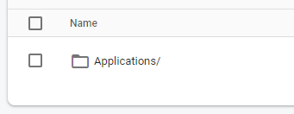

* 1. Disclaimer: If the “Applications/” folder is missing, it means that a file hasn’t been attached to an application yet. The folder will be created as soon as an application has a file uploaded to it. The Storage page does not dynamically update when a file is uploaded. You will need to refresh the page to see changes.
  2. Disclaimer: If you’re expecting an “Applications/” folder but can’t find one, it might mean someone else has deleted the folder.

1. You will be met with folders that are named with Application IDs

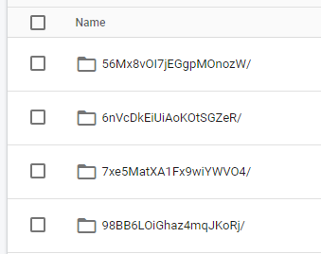

1. Copy the ID from the folder in the ZIP file. You can right-click and click on “rename” to copy the text.



1. Use CTRL + F in the Firebase tab and paste in the Application ID to find its folder.

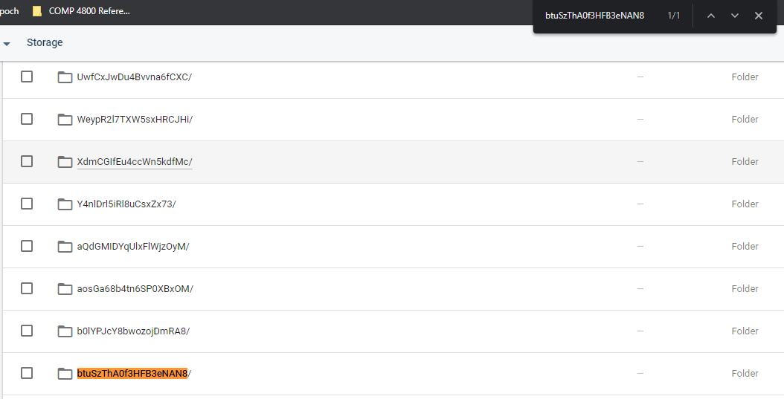

1. Click on the folder and cross check its contents with the contents in the ZIP file

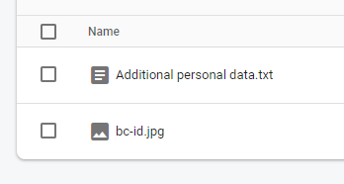



## Storing the ZIP file

From what has been discussed with PYCS the storage location for this backup file (the ZIP file) is an external hard drive. Please communicate with Ruth or the administrator for whoever currently has the external hard drive.

1. Before creating a copy of the ZIP file in the external hard drive please check the contents of the ZIP file to make sure that the application files have been downloaded
   1. For proper instructions on how to check if the contents of the ZIP file were downloaded properly, please check the section above on verifying ZIP files
2. Move the ZIP file into the external hard drive where the ZIP files are being stored
   1. There may be a specific way the external hard drive is set up to store the ZIP files. If this is the case, please follow the same or
3. After the transfer/copy is complete check the contents of ZIP file in the external hard drive to make sure the ZIP file has transferred/copied correctly
4. After verifying that the contents of the ZIP file are in the external hard drive you need to delete the ZIP file that still exist on the computer
   1. Make sure to delete file from the recycle bin as well to prevent it from being restored

# 

# File and Folder Navigation

## How to find a specific application folder in the Cloud Storage

1. Go to <https://console.firebase.google.com/> and log into the PYCS gmail
2. Under “YourFirebase projects” select “pycs-database-app”

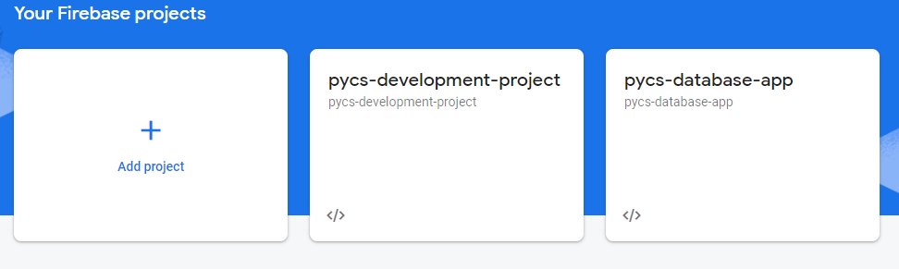

1. On the left bar select “Storage”

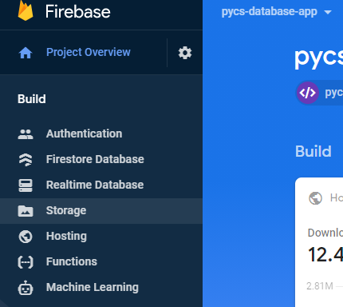

1. Click on “Applications” on the Storage page

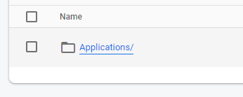

* 1. Disclaimer: If you DO NOT see an applications folder, this means it may have been recently deleted and no files have been uploaded to the Cloud Storage yet.   
     To resolve this a file MUST be uploaded to an application in order for the “Applications” folder to appear

1. You will see a list of folders. Each of these folders represents an application that has files uploaded to it.



1. Look for the folder in the ZIP that you want to search for in the database. In this example we’re searching for “56Mx8vOI7jEGgpMOnozW”



* 1. To copy the ID you can right click a folder and click “rename” to copy the text

1. Go back to the cloud storage and CTRL + F the application id to find the corresponding folder

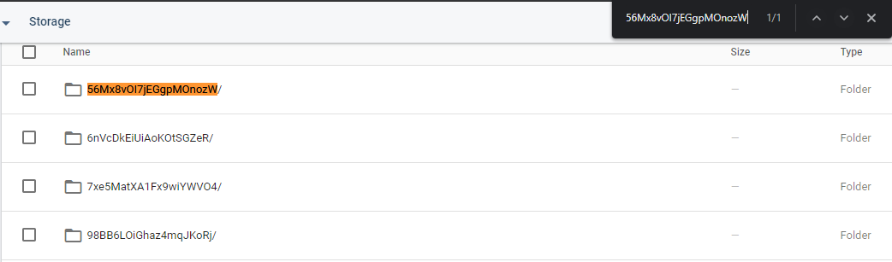

1. At this point you can decide what you would like to do. You can open the folder to verify the contents with the contents in the ZIP file. You can delete the folder in the Storage to remove it completely.
   1. Warning: Deleting a folder means you will be permanently deleting these files. Make sure you create a backup before deleting an entire folder.

## How to delete the Cloud Storage to make more space

Warning: Following these instructions will permanently delete all files from all applications. You will be unable to recover these files without a backup.

Warning: It is important that the staff of PYCS are aware when the Firebase storage is cleared. There may be some conflict with staff if a recently stored file is missing. Someone would have to look in the external hard drive to find the file if this is the case. While it is convenient to delete the entire storage at once please be wary of the staff it is affecting.

**Please create a backup before completing the following steps**

1. Go to <https://console.firebase.google.com/> and log into the PYCS gmail
2. Under “YourFirebase projects” select “pycs-database-app”



1. On the left bar select “Storage”



1. Click on “Applications” on the Storage page



* 1. Disclaimer: If you DO NOT see an “Applications” folder, this means it may have been recently deleted and no files have been uploaded to the Cloud Storage yet.

1. Check the checkbox to select the “Applications” folder and click on the “Delete” button

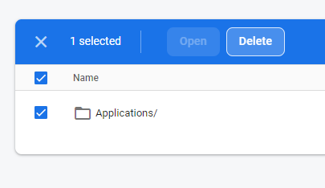

1. You should see this after you’ve successfully delete all the files

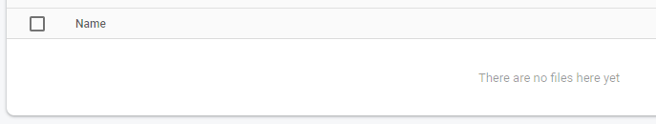

# Firebase Cloud Storage Management Suggestions

## Introduction

Some management suggestions for PYCS from the BCIT team (group 2).

## Data storage and transfer limits

As of 2021/05/24 Firebase offers up to 10 GB of storage total and 10 GB/month for transferring files. The largest file size that can be uploaded to the Storage is 2 GB.

## Suggestions

We suggest downloading a backup file at least once every month or two weeks. So at the end of a year you would have at least 12/24 backup files.

When accessing the Firebase project there will be an indicator for how much storage has been used. This is located in the “pycs-database-app” project in the “Project Overview” tab.

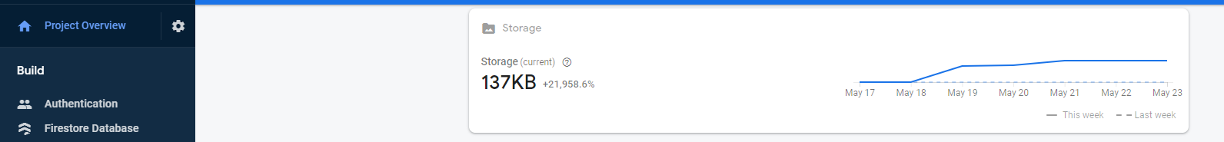

The amount of storage used should be monitored and noted down on file backup days.

There are two plans we’ve created already for managing the storage.

Disclaimer: Regardless of what plan you decide to do you should be weary of how much space is being used in the storage. The more being used means the longer it will take the backup file to download.

### Storage Plan: One download every month

On the third last day of the month you download a backup of the storage. The third last day so there’s room for error if the person responsible has forgotten or there are still some Firebase Storage adjustments you want to make before downloading all the data.

Details:

* Download one backup file on every third last day of the month
* Make sure the storage doesn’t exceed 4.5 GB
* When the database nears 4.5 GB, but you’re not nearing you schedule date for clearing the database, you will have to do an impromptu storage clearing

### Storage Plan: One download every two weeks

On the 14th and 28th of a month you download a backup of the storage. This may be a little excessive and not required. This option is written because having shorter wait times between backup files will ensure your losses (if they ever occur) in files will cover only two weeks instead of a whole month.

Details:

* Download two backup files. One on the 14th of the month and the other on the 28th
* Make sure the database doesn’t exceed 2 GB
* When the database nears 2 GB, but you’re not nearing you schedule date for clearing the database, you will have to do an impromptu storage clearing

Disclaimer: Why is the storage limit in your plans limited to 4.5/2 GB? This is because in the case the storage nears those sizes we want to make sure we don’t go over our transfer limit for the month. On the chance that a problem occurs on the first attempt to download the files you will have another chance to download the files again. For the “once a month” plan at worst if your first attempt fails to download you will have another 5.5 GB for the month to attempt a second download. As for the “once every two weeks” plan you will have another 8 GB for the month to attempt a second download (this is the download schedule on the 14th), and for the second scheduled download (the download scheduled for the 28th) you will have an additional 4 GB for the month to attempt a second download.

## 

# Author Notes

Written by the BCIT development team (Group 2)

Author: Brian D. (@2021)

The PYCS gmail should have access to edit this document. If this is not the case, please contact the author or development team members

Last updated: 2021/05/24